**Software System for Hailing Cab**

UCS2201 – Fundamentals and Practice of Software Development

A PROJECT REPORT

Submitted By

KEERTHANA G S (3122225001059)

KEERTHANA K (3122225001060)

KEERTHANA S (3122225001061)

Department of Computer Science and Engineering

Sri Sivasubramaniya Nadar College of Engineering

(An Autonomous Institution, Affiliated to Anna University)

Kalavakkam – 603110

July 2023

**Sri Sivasubramaniya Nadar College of Engineering**

**(An Autonomous Institution, Affiliated to Anna University)**

**BONAFIDE CERTIFICATE**

Certified that this project report titled “SOFTWARE SYSTEM FOR HAILING CAB”is the bonafide work of “KEERTHANA G S (3122225001059), KEERTHANA K (3122225001060) and KEERTHANA S (3122225001061)” who carried out the project work in the UCS2201 – Fundamentals and Practice of Software Development during the academic year 2022-23.

Internal Examiner External Examiner

Date:

**TABLE OF CONTENTS**

**TABLE OF CONTENTS:**

INTRODUCTION: 4

SYSTEM OVERVIEW: 4

SYSTEM PROCESS: 5

PROBLEM STATEMENT: 6

USE CASE DIAGRAM: 7

ACTIVITY DIAGRAM 8

DATA FLOW DIAGRAM 8

RATIONALE BEHIND THE SELECTION OF A STRUCTURES CONSTRUCT(ARRAYS, STRUCTURES, ARRAY OF STRUCTURES, FILE ETC) 10

PLATFORM USED FOR CODE DEVELOPMENT: 11

IMPORTANT MODULES USED IN OUR CODE: 11

INTERFACE DIAGRAM 15

OUTPUTS 19

LIMITATIONS OF CAB HAILING SYSTEM 27

SOCIAL PERSPECTIVES: 27

LEGAL PERSPECTIVES: 28

ENVIRONMENTAL PERSPECTIVES: 28

LEARNING OUTCOMES 28

INTRODUCTION:

The approach in which riders and drivers are available on a single platform is known as online taxi booking. Riders can hire a vehicle in a single click to travel to any place by selecting their preferred vehicle type. The nearest driver will accept the booking. The customer is then picked up and dropped off at their location by the driver. The online cab booking system makes traveling easier in this digital age by allowing you to move from one location to another with a single tap.Each year, cities grow larger, and life within runs increasingly faster. For millions of citizens, owning a personal car can be costly and harmful to the environment. A taxi, however, is the number one transportation option, as it allows them to reach their destination in time, no matter how early, late, or busy it is.Today’s taxi booking apps allow users to take a taxi at a set time, calculate the arrival time based on the traffic situation, track the car route, and pay for the ride at the touch of a button.

SYSTEM OVERVIEW:

Book a cab is the first site in India, which provides reliable online(web based)cab(car) booking facility to people in various cities in India, free of cost. Book a cab acts like a bridge between the cab operators and the customers/users/people who book a cab. This is the online cab booking service provided to customers. This brings together the registered travel agencies/ cab operators/car owners and the customers this app provides this service for free of cost i.e, we provide free registration for the cab owners, and free service to the travelers/customers/users who go for booking a cab or car or taxi. Here the customers can book a cab /taxi/car by viewing all the cab details and pricing details available, according to selected city and area. It is the reliable service provided to both customers and Travel agencies. This provides service with well-conditioned new vehicles, with experienced drivers for a happy journey of the customers .Through this app you can book a taxi from anywhere in India. It has registered travels or cab operators from all famous cities throughout Chennai.

SYSTEM PROCESS:

**CAB SEARCH:**

User can search cab for a particular location here. User required to enter Source, Destination, and Place where he want to go.

**LOGIN PROCESS:**

In this the customer has to give out the login details i.e. user id and password and then only he can be logged on. The user id and password given by the customer are checked from the data stored in the database

**ADMINISTRATION PROCESS:**

In this process Administrator will upload the availability of cab information in the database. It includes place, services, and cost of the available cab. Cab availability will be viewed by the customer after he has logged on to the site.

**THE OBJECTIVES OF AN ONLINE TAXI BOOKING SYSTEM:**

1. Convenience for Customers
2. Bringing Riders and Drivers Together
3. Booking a taxi is simple.
4. To make traveling easier to enjoy when scheduling benefits and offers
5. To assist around the clock
6. Riding safely and securely
7. Simple payment methods
8. Customer satisfaction is the goal.
9. Booking without stress

PROBLEM STATEMENT:

Develop a software system for assigning cabs for customers based on their requests and locations. The customers are charged a fixed base fare plus fare based on the distance travelled . During peak demand time, a surge fee also will be charged.Apart from this, if the customer books the vehicle in advance, advance booking fees will be charged. If the customer cancels the ride for some reason, a cancellation fee will be charged.

The software system for assigning cabs to customers based on their requests and locations can be expanded as follows:

**USER MANAGEMENT:**

Implement user signup and login functionality for customers to create accounts and access the cab booking system.

**CAB MANAGEMENT**:

* Maintain a database of available cabs with details like cab type (e.g., Mini, Sedan, SUV), and driver information.
* BOOKING SYSTEM:
* Provide an interface for customers to enter their pickup and drop-off locations.
* Implement a distance calculation algorithm to estimate the fare based on the distance traveled.
* Apply a fixed base fare and per-kilometer rate to calculate the total fare for the ride.
* Integrate with a payment gateway to process secure payments and generate digital receipts for customers.

**PEAK DEMAND MANAGEMENT:**

* Identify peak demand hours and implement a surge pricing mechanism to charge customers an additional fee during those times.
* Notify customers about surge pricing before confirming their bookings.

**ADVANCED BOOKING:**

* Allow customers to schedule rides in advance, specifying the date for pickup.
* Apply advance booking fees based on the selected time frame.

**CANCELLATION POLICY:**

* Charge customers a cancellation fee if they cancel the ride after a specified time threshold.

**RATING AND FEEDBACK**:

* Provide a rating system for customers to rate their ride experience and provide feedback on drivers and the overall service.
* Display average driver ratings to help customers make informed decisions when booking cabs.

USE CASE DIAGRAM:

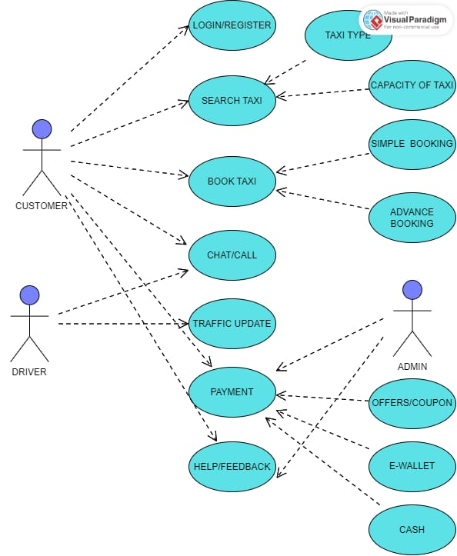

* In a cab booking system's use case diagram, the main actors are the Customer, Driver, Admin.
* The Customer represents users who want to book a cab, the Driver represents the drivers who fulfill the ride requests, and the Admin represents the system administrator responsible for managing the cab booking system.

ACTIVITY DIAGRAM

* The activity diagram for a cab booking system visually represents the flow of activities and actions involved in the process of booking a cab.
* It focuses on the behavior of the system from the user's perspective and shows the sequence of steps taken during the cab booking process.

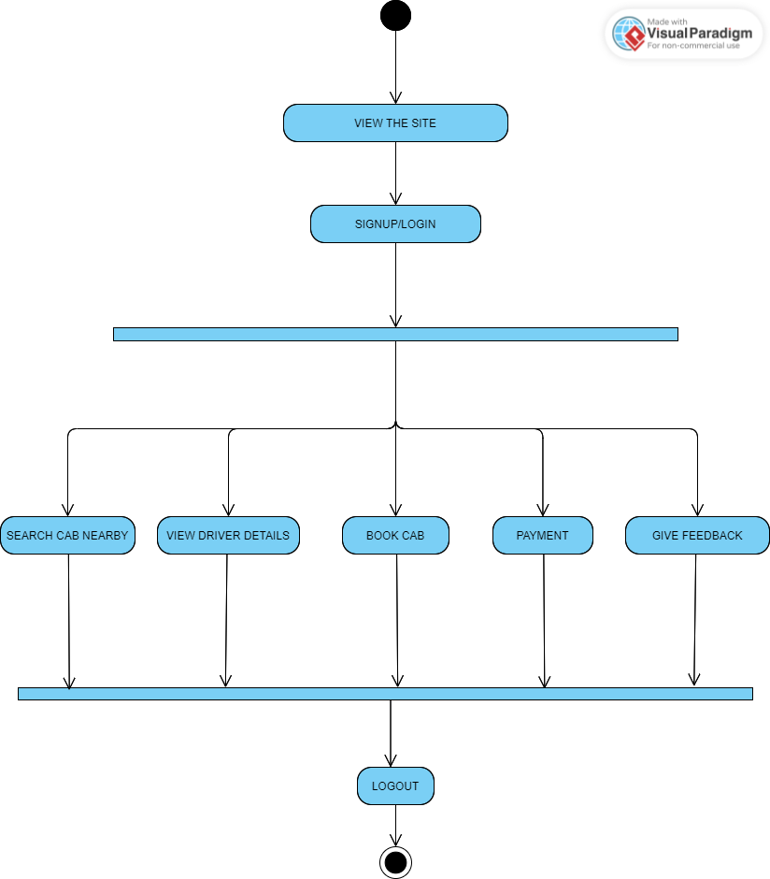

DATA FLOW DIAGRAM

* The Data Flow Diagram (DFD) for a cab booking system is a visual representation that outlines the flow of data between various components of the system.
* The DFD showcases the interactions between external entities, such as passengers and drivers, and the internal processes that handle tasks like booking a cab, processing payments, and managing reservations.

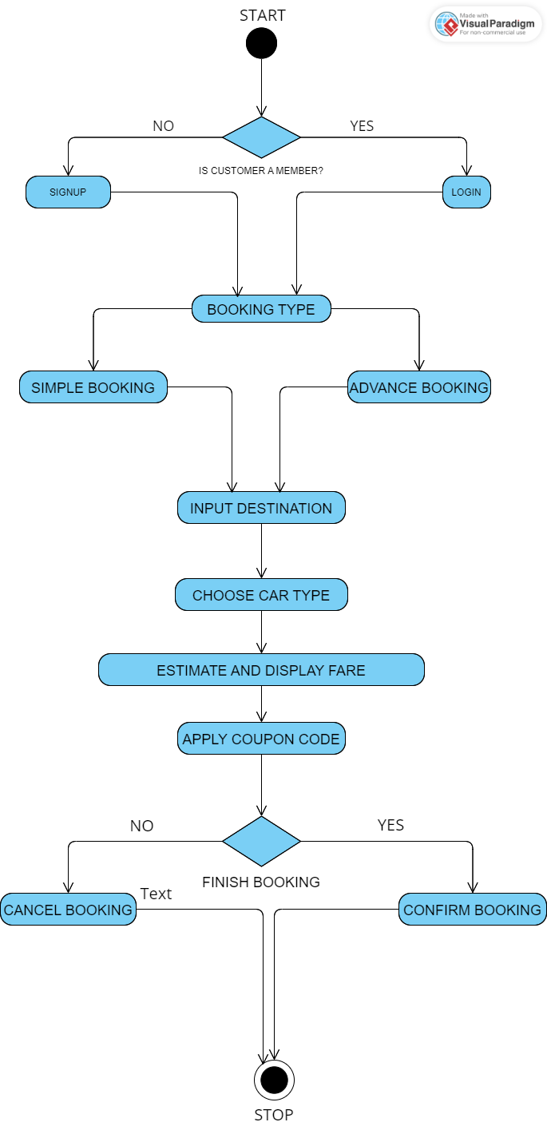

RATIONALE BEHIND THE SELECTION OF A STRUCTURES CONSTRUCT(ARRAYS, STRUCTURES, ARRAY OF STRUCTURES, FILE ETC)

* Structures allow grouping related data together, enabling convenient access and manipulation. In this code, they are used to organize and represent user information, location details, and driver data.
* Using structures of arrays provides several advantages:
* It allows for the grouping of related data together, making it easier to manage and access.
* It enables efficient memory allocation since all the data for a particular entity (user or driver) is stored consecutively in memory.
* Arrays provide efficient random access to elements, allowing for convenient retrieval and manipulation of data.
* It simplifies passing and handling data to/from functions since arrays can be easily passed as arguments.
* Structures allow you to define a custom data type that can hold multiple fields or attributes
* Arrays of structures help in organizing data in a structured manner.
* The use of structures and arrays of structures provides an organized approach for storing and accessing related data elements, facilitating efficient data management and manipulation.

**IN THE PROVIDED CODE, STRUCTURES ARE USED FOR VARIOUS PURPOSES:**

**USER STRUCTURE:**

* The structure named "User" is used to store the username and password for each user during signup and login processes.
* An array of User structures called "users" is used to store multiple user records.

**PLACE PICK AND PLACE DROP STRUCTURES:**

* The structures "place_pick" and "place_drop" are used to represent the pickup and drop-off locations respectively.
* They store the name, latitude, and longitude of each location.
* Arrays of these structures are used to store multiple predefined pickup and drop-off locations.

**DRIVER STRUCTURE:**

* The "drivers" structure is used to store information about drivers, including their names, latitude, longitude, and ratings.
* An array of driver structures called "near" is used to store details of nearby drivers.
* The "rating" field in the structure is later used to store the user's rating for a particular driver.

PLATFORM USED FOR CODE DEVELOPMENT:

* For the development of our code, we opted to use Visual Studio Code (VS Code) as our primary platform.
* With VS Code's user-friendly interface and powerful tools, we were able to collaborate seamlessly and efficiently develop our cab booking system.

IMPORTANT MODULES USED IN OUR CODE

**CALCULATE DISTANCE MODULE:**

double toRadians(double degree) {

return degree * M_PI / 180.0;

}

double calculateDistance(double lat1, double lon1, double lat2, double lon2) {

double dLat = toRadians(lat2 - lat1);

double dLon = toRadians(lon2 - lon1);

double a = sin(dLat / 2) * sin(dLat / 2) + cos(toRadians(lat1)) * cos(toRadians(lat2)) * sin(dLon / 2) * sin(dLon / 2);

double c = 2 * atan2(sqrt(a), sqrt(1 - a));

return RADIUS * c;

}

double distance = calculateDistance(lat1, lon1, lat2, lon2);

toRadians Function:

* This function takes an input degree value and converts it to radians.
* It multiplies the degree value by M_PI / 180.0 to convert it from degrees to radians.
* The resulting value is returned.

calculateDistance Function:

* This function calculates the distance between two locations specified by their latitude and longitude coordinates.
* It takes four parameters: lat1 and lon1 represent the latitude and longitude of the first location, and lat2 and lon2 represent the latitude and longitude of the second location.
* The latitude and longitude differences are converted to radians using the toRadians function.
* The Haversine formula is then used to calculate the distance between the two locations based on their latitude and longitude differences.
* The calculated distance is returned.

**ADVANCE BOOKING MODULE:**

int advancedBooking;

printf("************\n");

printf("\nDO YOU WANT TO MAKE AN ADVANCED BOOKING?\n");

printf("1. NO ADVANCED BOOKING\n");

printf("2. 1-DAY ADVANCED BOOKING\n");

printf("3. 2-DAY ADVANCED BOOKING\n");

printf("4. 3-DAY ADVANCED BOOKING\n");

printf("ENTER YOUR CHOICE: ");

scanf("%d", &advancedBooking);

double advancedBookingCost = cost1;

if (advancedBooking == 2) {

advancedBookingCost += 150.0;

} else if (advancedBooking == 3) {

advancedBookingCost += 300.0;

} else if (advancedBooking == 4) {

advancedBookingCost += 400.0;

}

printf("\n");

if (advancedBooking != 1) {

printf("TOTAL COST FOR THE CAB RIDE WITH ADVANCED BOOKING IN INR: %.2lf\n", advancedBookingCost);

} else {

printf("TOTAL COST FOR THE CAB RIDE IN INR: %.2lf\n", cost);

}

* In this module this code uses an if-else if structure instead of a switch statement to calculate the advancedBookingCost . The logic remains the same:
* The user is prompted to select an advanced booking option.
* Based on the selected option, the advancedBookingCost is calculated by adding the corresponding extra charges to cost1.
* The calculated cost is then displayed based on whether advanced booking was selected or not.

**PEAK TIME MODULE:**

int peak() {

int cost = calculateCabCost(cabType, distance);

int extra_charges = 0;

int tot = 0;

time_t currentTime;

struct tm *localTime;

time(&currentTime);

localTime = localtime(&currentTime);

localTime->tm_hour += 5;

localTime->tm_min += 30;

if (localTime->tm_min >= 60) {

localTime->tm_min -= 60;

localTime->tm_hour += 1;

}

localTime->tm_hour %= 24;

printf("CURRENT INDIAN TIME: %02d:%02d:%02d\n", localTime->tm_hour, localTime->tm_min, localTime->tm_sec);

if (localTime->tm_hour > 7 && localTime->tm_hour < 22) {

printf("AS THIS IS THE PEAK TIME, EXTRA CHARGES WILL BE APPLIED FOR THE RIDE.\n");

extra_charges = 100;

tot = extra_charges + cost;

printf("THE COST IS: %d\n", cost);

printf("THE PEAK TIME CHARGE IN INR: %d\n", extra_charges);

printf("THE TOTAL COST (INCLUDING PEAK TIME CHARGE) IS: %d\n", tot);

} else {

printf("NO EXTRA CHARGES WILL BE APPLIED AS IT IS NOT THE PEAK TIME.\n");

extra_charges = 0;

tot = extra_charges + cost;

printf("THE TOTAL COST IS: %d\n", tot);

}

return tot;

}

* The peak() function is defined with an int return type.
* It begins by calculating the initial cost of the cab ride using the calculateCabCost() function, assuming the variables cabType and distance have been defined.
* The current Indian time is printed using the values from localTime->tm_hour, localTime->tm_min, and localTime->tm_sec.
* If the current hour is between 7 and 22 (inclusive), it is considered peak time. Extra charges of 100 are applied, and the total cost is calculated by adding the extra charges to the initial cost.

INTERFACE DIAGRAM

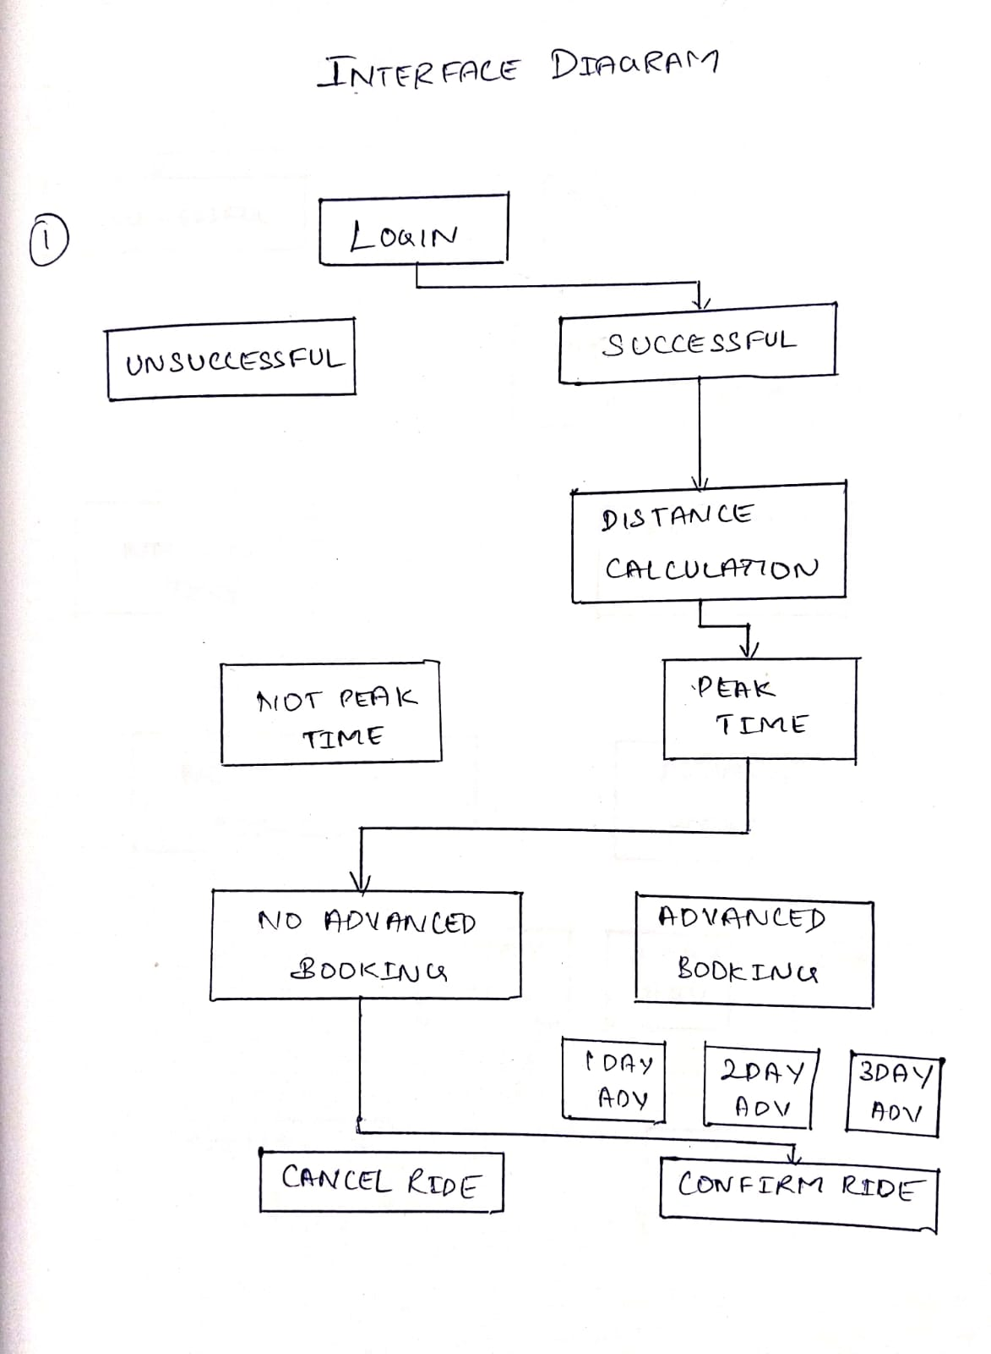

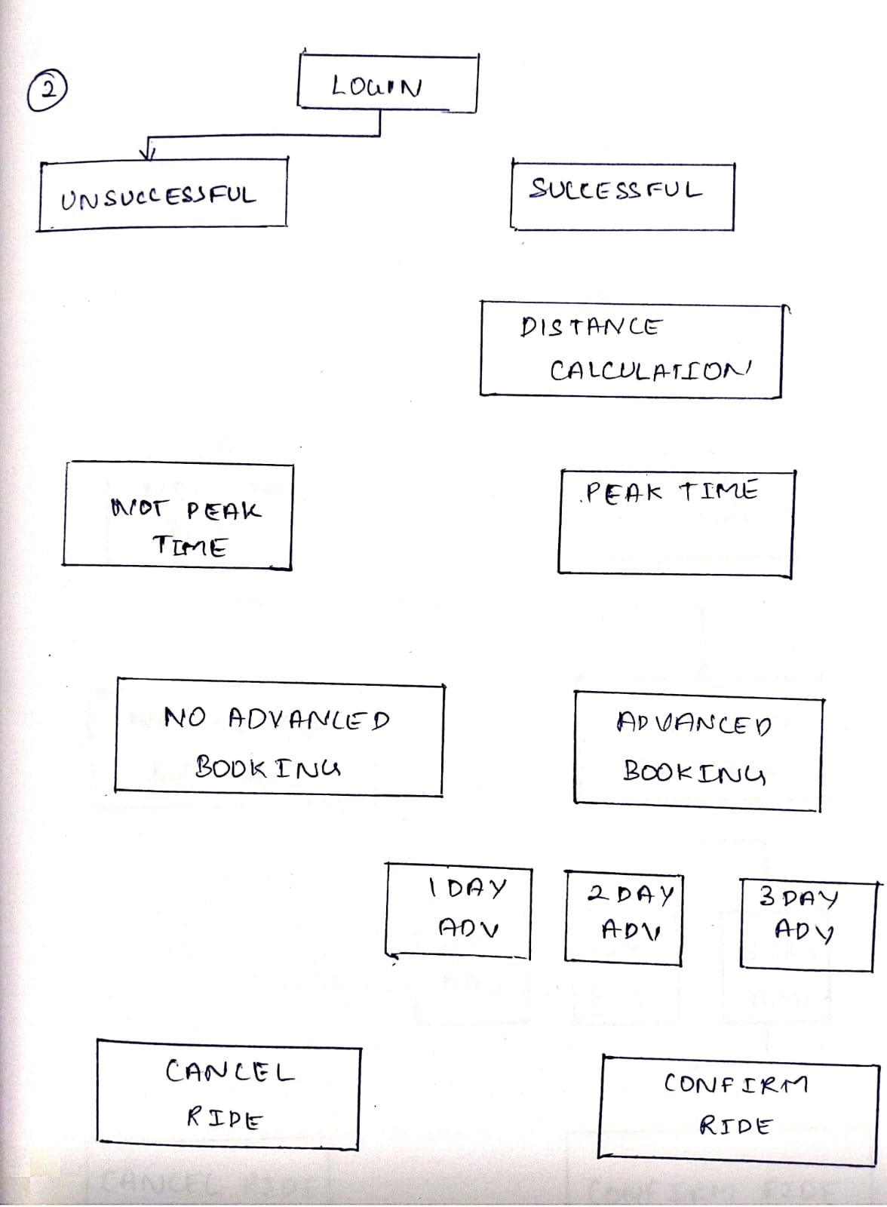

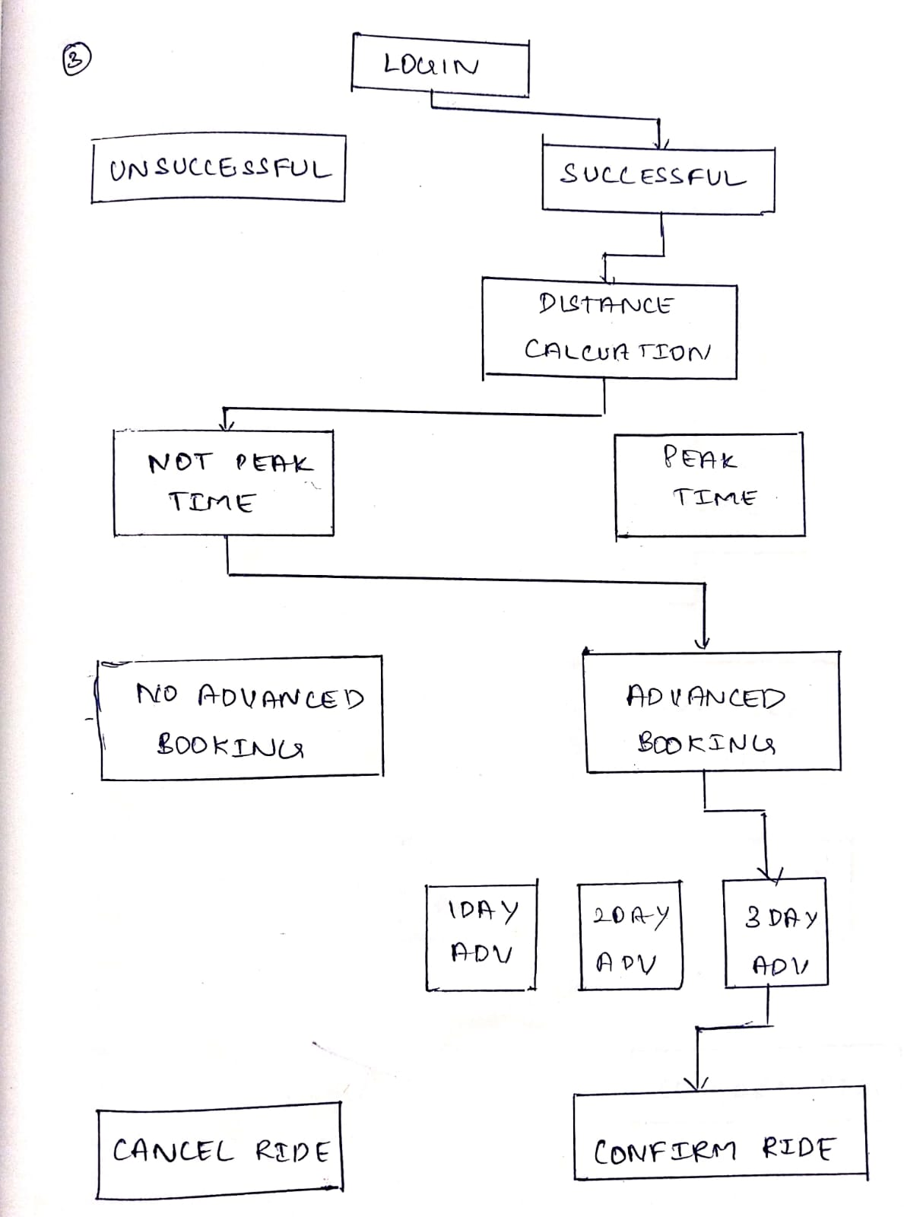

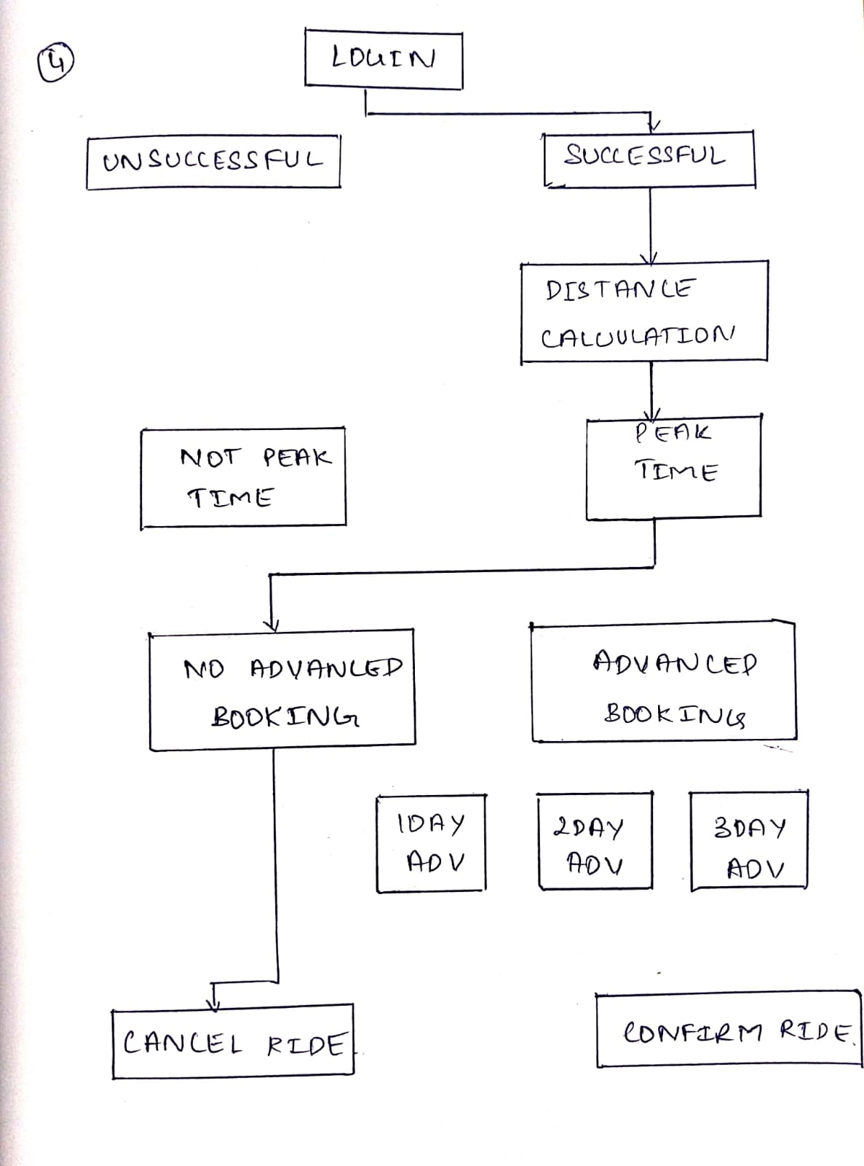

OUTPUTS

1)

* Login successfull
* No peak time charges
* Choosing mini as the car type
* No advance booking
* 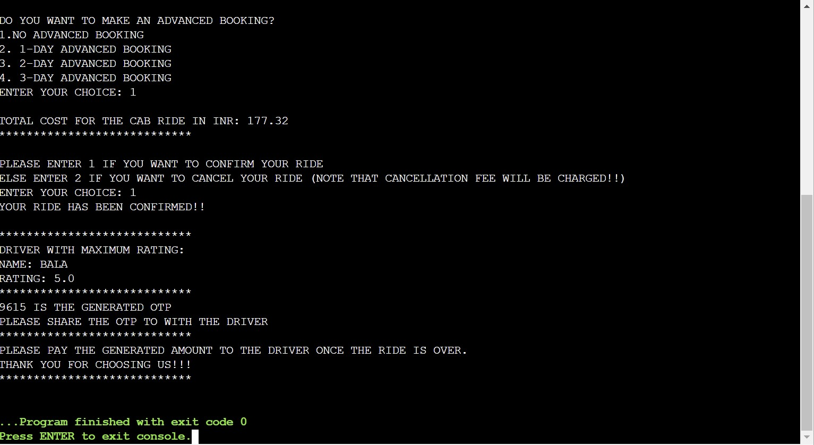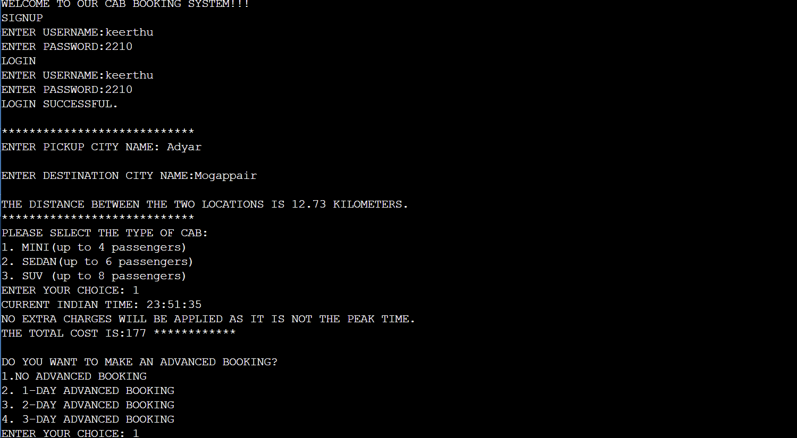Confirm the ride

2)

* Login successfull
* No peak time charges
* Choosing sedan as car type
* 1-day advance booking
* 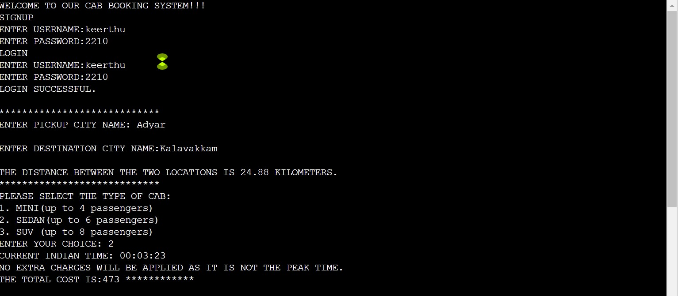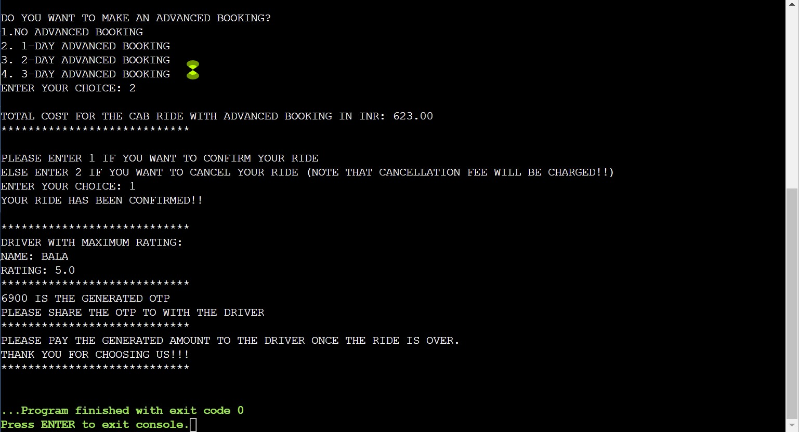Confirm the ride

3)

* Login successfull
* Peak time charges
* Choosing suv as car type
* 2-day advance booking
* 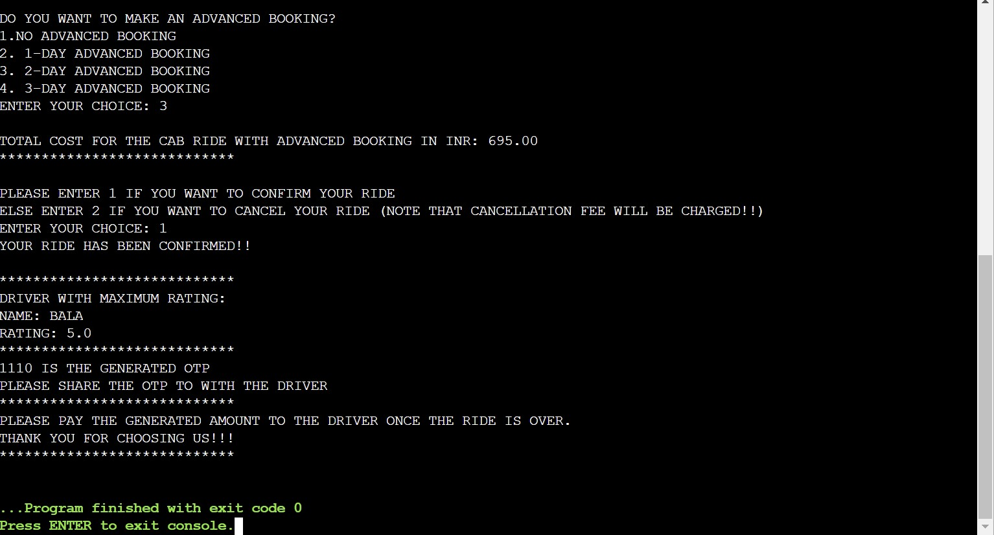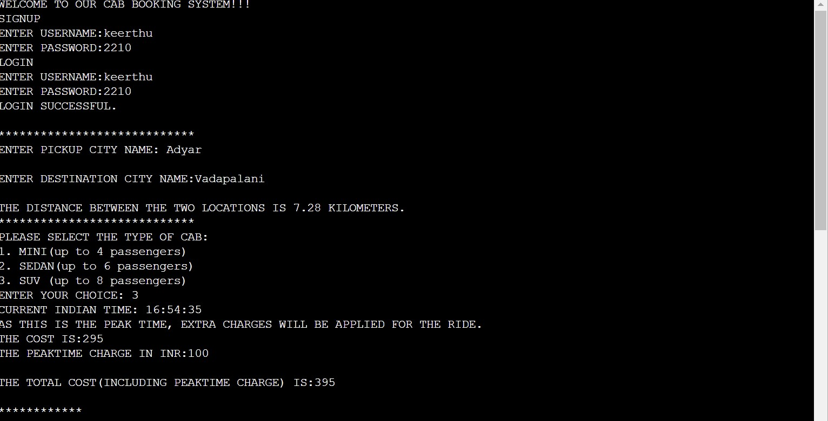Confirm ride

4)

* Login successfull
* No peak time charges
* Choosing mini as car type
* No advance booking
* 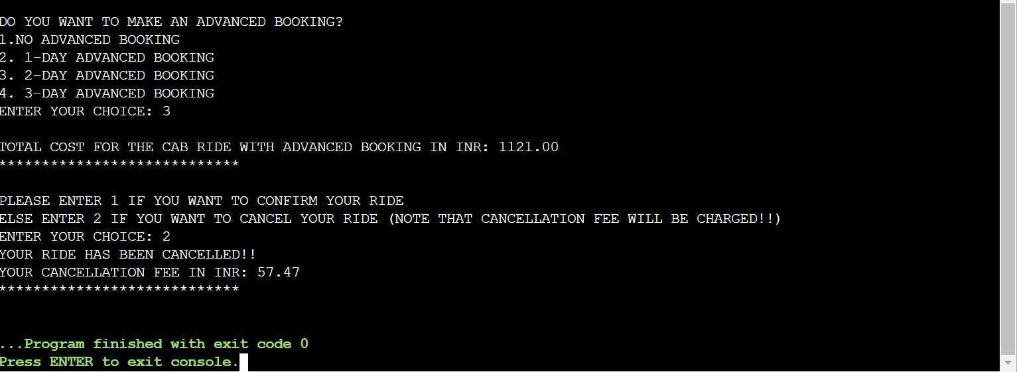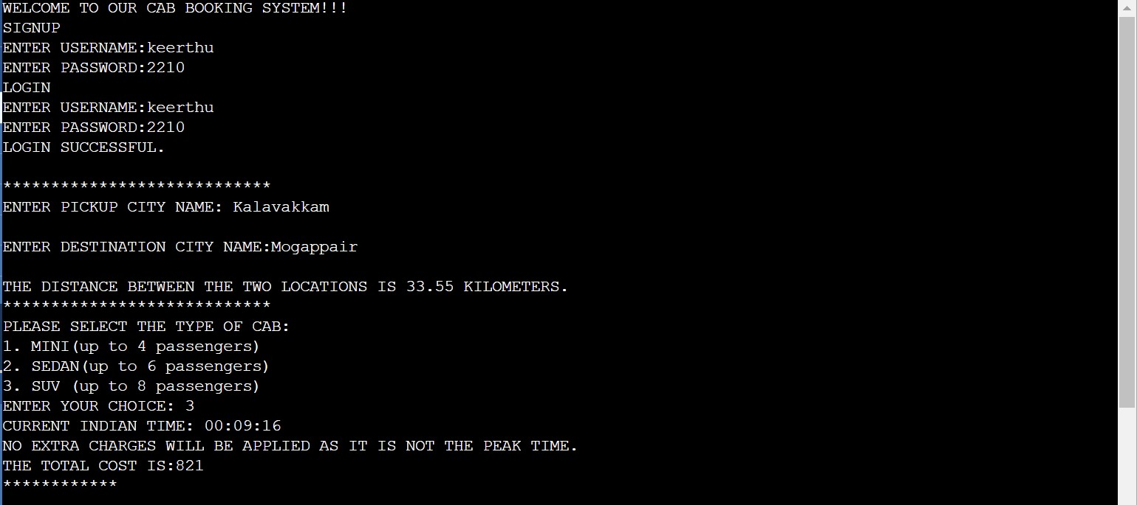Finally cancel the ride

5)Login unsuccessful

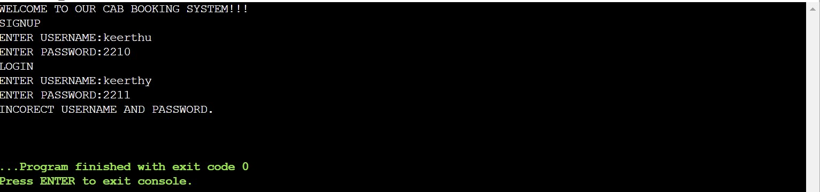

6)

* Login successfull
* No peak time charges
* Choosing mini as car type
* Add coupon code
* No advance booking
* 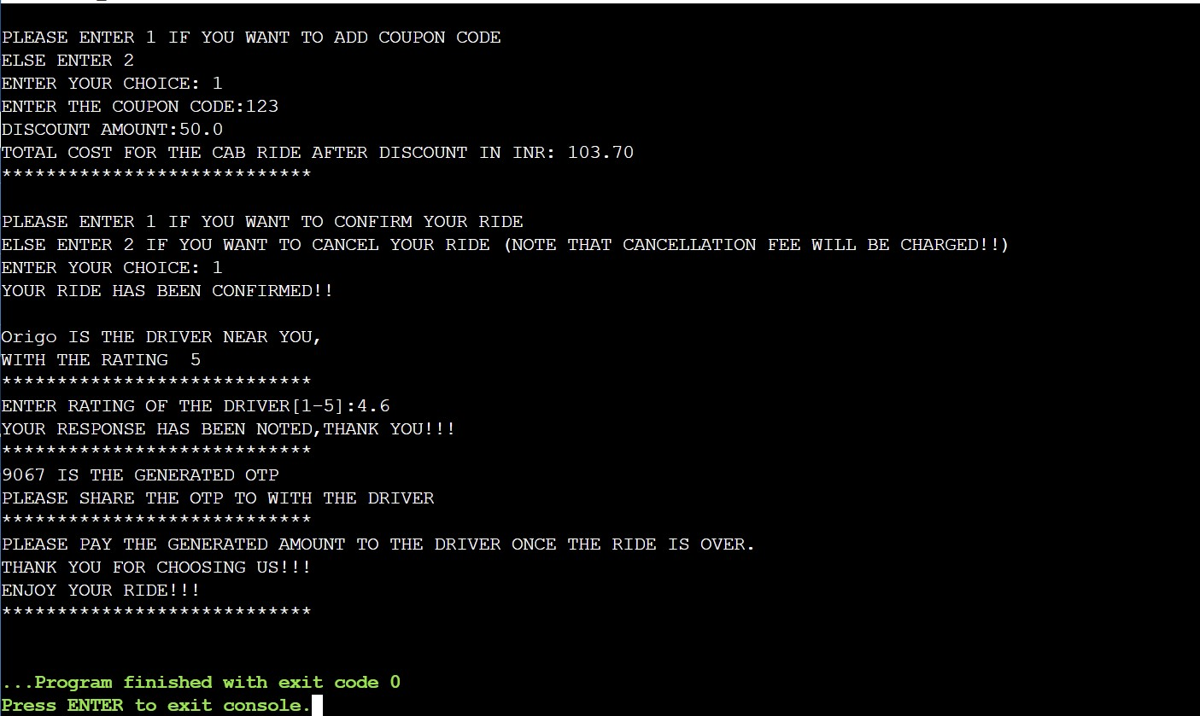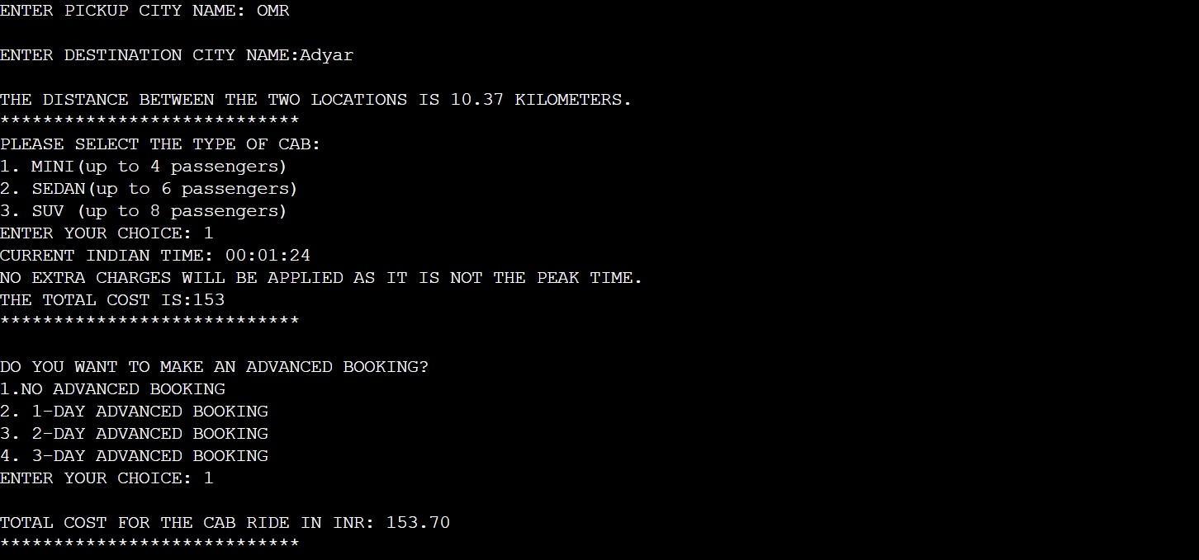Confirm booking

7)

* Login successfull
* No peak time charges
* Choosing sedan as car type
* 1-day advance booking
* No coupon code
* 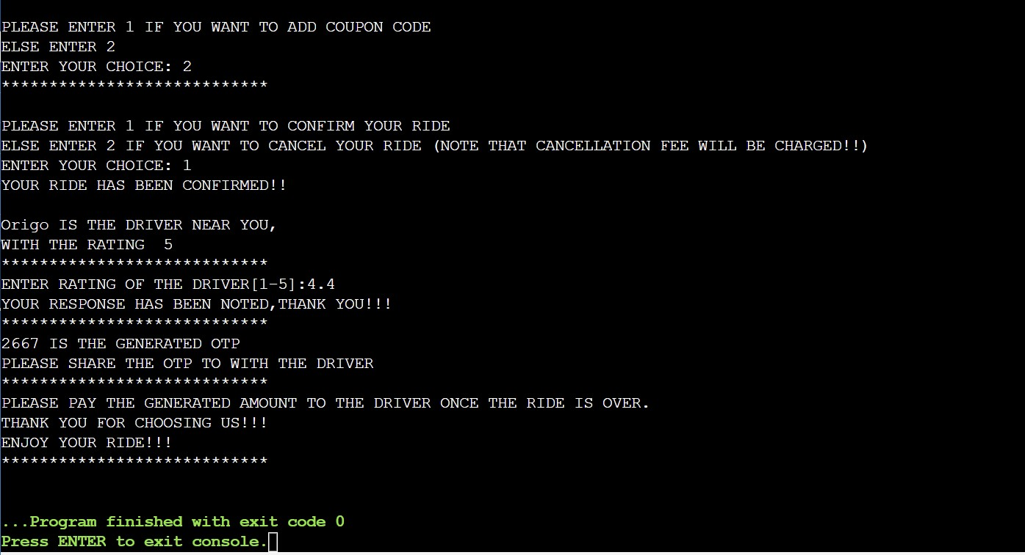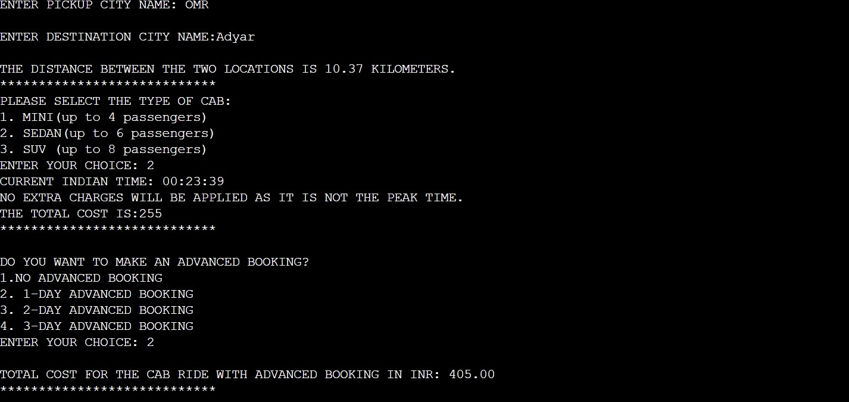Confirm booking

8)

* Login successfull
* No peak time charges
* Choosing suv as car type
* 2-day advance booking
* No coupon code
* Cancel booking

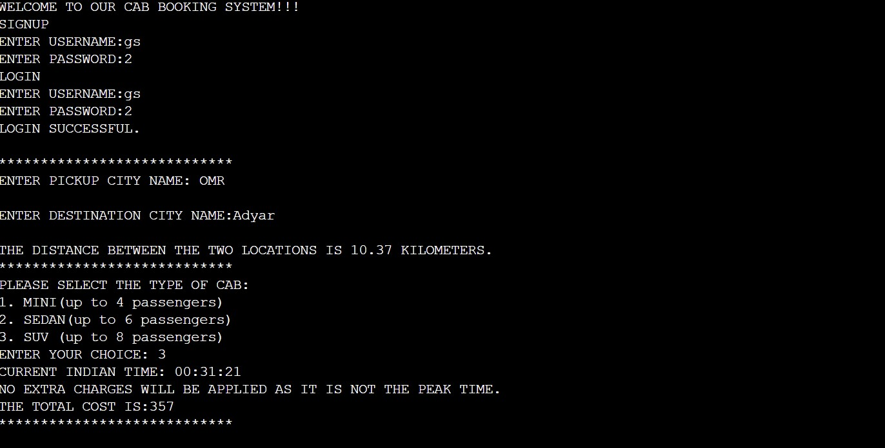

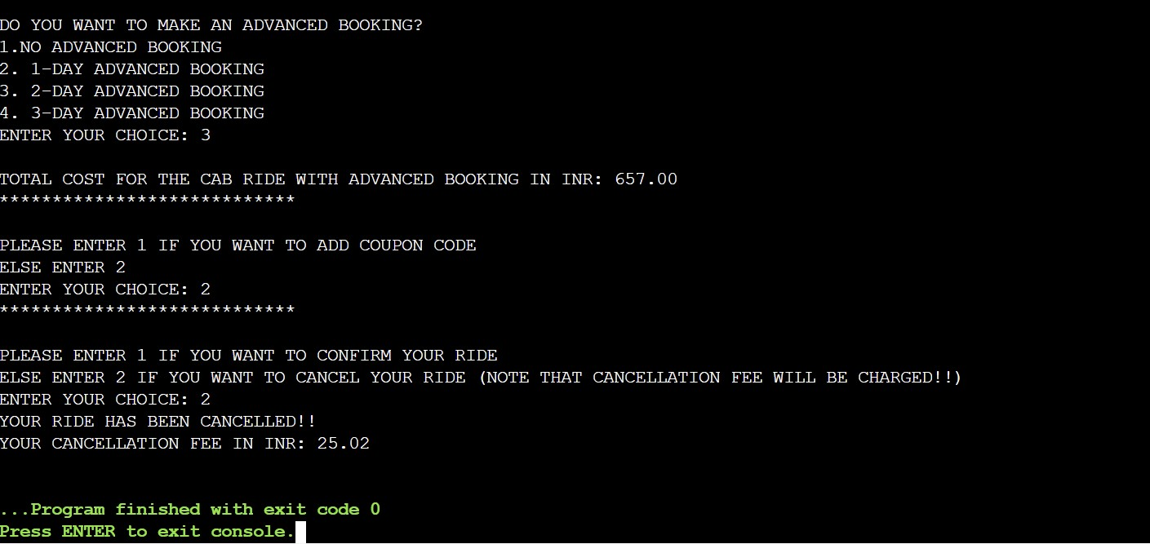

9)

* Login successfull
* No peak time charges
* Choosing sedan as car type
* 3-day advance booking
* Add coupon code
* 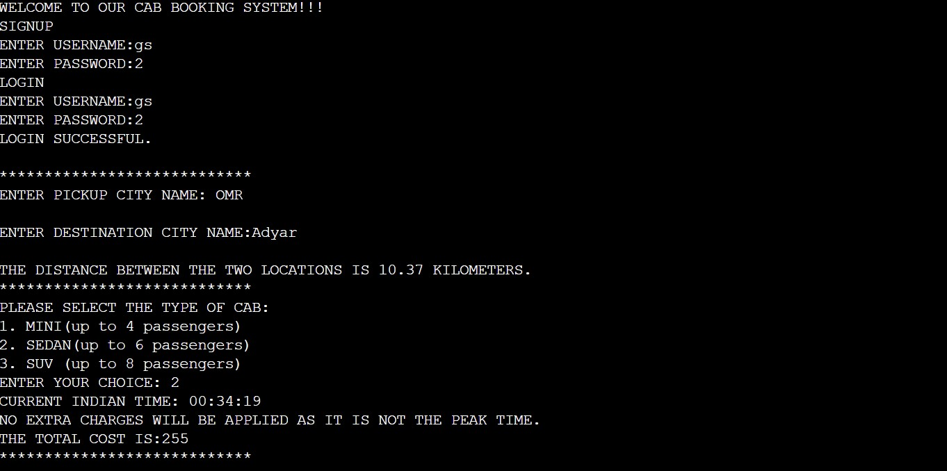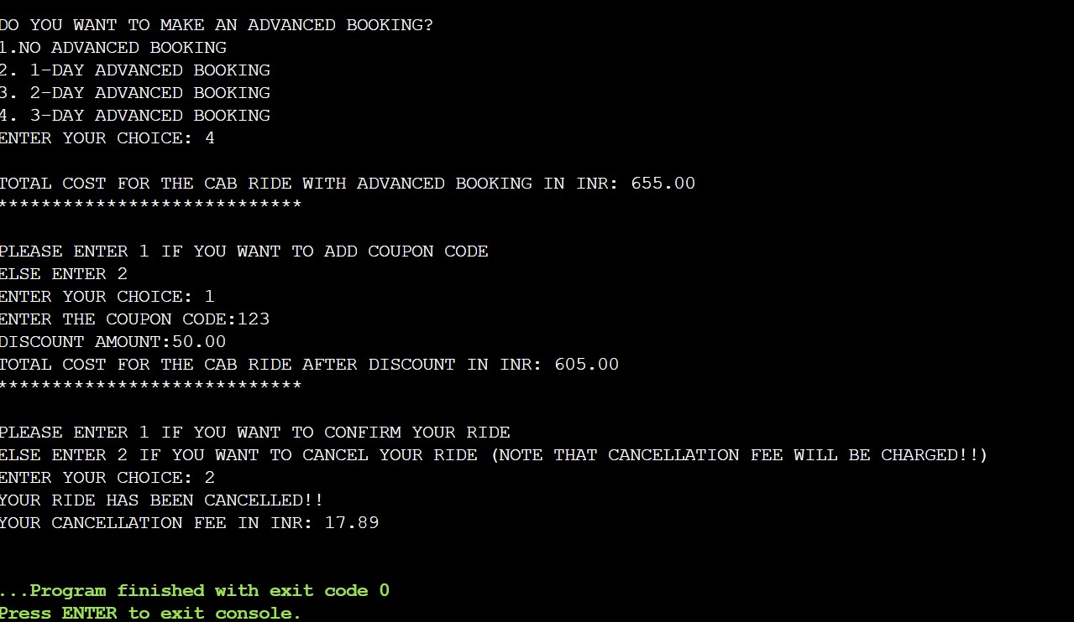cancel booking

LIMITATIONS OF CAB HAILING SYSTEM

1. Limited availability in certain areas.
2. Surge pricing during high-demand periods.
3. Dependence on internet connectivity for booking and tracking.
4. Limited payment options.
5. Safety concerns.
6. Reliance on drivers for service quality.
7. Lack of control over vehicle selection.
8. Potential driver cancellations or no-shows.
9. Language barriers for international travellers.
10. Possibility of incorrect fare calculations.
11. Restricted service hours in some locations.
12. Difficulty accommodating large groups or special needs.
13. Lack of transparency in driver ratings and reviews.
14. Privacy concerns with personal information shared during booking.

SOCIAL PERSPECTIVES

1. Increased transportation accessibility for individuals without private vehicles.
2. Creation of employment opportunities for drivers.
3. Implementation of safety measures, such as driver background checks.
4. Convenience and ease of use for passengers.
5. Reduction in drunk driving incidents by providing an alternative transportation option.
6. Facilitation of social interactions by connecting passengers with drivers from diverse backgrounds.

LEGAL PERSPECTIVES

1. Regulatory Challenges
2. Licensing and Insurance

3.Data Privacy

ENVIRONMENTAL PERSPECTIVES

1. Reduced Individual Car Ownership
2. Potential for Green Initiatives
3. Efficient Routing and Ride Sharing
4. Impact on Public Transportation

These points provide a broad overview of the social, legal, and environmental perspectives of cab hailing systems.

LEARNING OUTCOMES

1. Implementing Algorithms
2. File Handling
3. Language constructs(Arrays, Structures, Array of Structures)
4. Handling User Input
5. Memory
6. Error Handling and Debugging

By studying cab hailing systems in C programming, you gain practical experience in implementing real-world applications, improve your problem-solving abilities, and enhance your overall proficiency in the C programming language.

THANK YOU!!!